**SECTION 8: RFI CLARIFICATION REQUEST FORM**

**RFI No: HOAC-HO-49860**

Deadline for RFI clarification submissions: Before **12:00 pm on** 20 March 2025

TO: Transnet SOC Ltd

ATTENTION: Buyisiwe Hlatshwayo

EMAIL buyisiwe.hlatshwayo@transnet.net

DATE: 27 February 2025

FROM:

RFI Clarification No [to be inserted by Transnet] ……..

**REQUEST FOR RFI CLARIFICATION**:

SECTION 6: CERTIFICATE OF ACQUAINTANCE WITH RFI, TERMS & CONDITIONS & APPLICABLE DOCUMENTS

Section 6 contains the following table of Annexures:

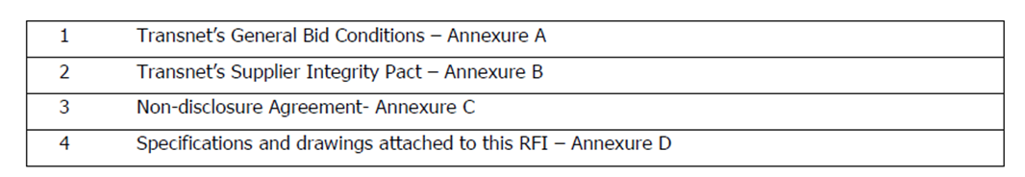

This table is inconsistent with the file names of the documents which are available for download on both the eTender website and the TransneteTenders website, which are as follows:

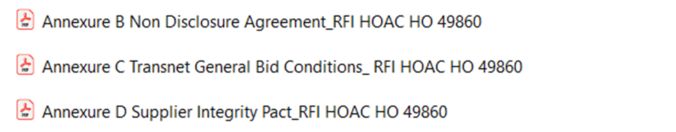

Can Transnet please advise:

1. The correct Annexure naming convention,
2. Where item number 4 in the Section 6 table: Annexure D – ’Specifications and drawings attached to this RFI’ is located.

**Transnet Reply:**

1. There was an error on this table please consider the below as captured on the initial RFI.

|  |
| --- |
| 1. TECHNICAL SUBMISSION / QUESTIONNAIRE – Annexure A |
| 1. SCOPE OF REQUIREMENTS TO THIS RFI/EOI – Section 3 |
| 1. TRANSNET’S GENERAL BID CONDITIONS - Annexure B |
| 1. NON-DISCLOSURE AGREEMENT- Annexure C |
| 1. TRANSNET’S SUPPLIER INTEGRITY PACT – Annexure D |

1. Please refer to the above table for correct naming of documents included on the RFI